The Guardians
Meet Our Trustees
The Acharya Shanti Sagar Foundation is guided by a dedicated group of trustees who bring diverse expertise, deep values, and genuine commitment to our mission.These are individuals who have built successful enterprises while remaining committed to social responsibility, cultural preservation, and community welfare. They lead this foundation not as an obligation, but as a calling.
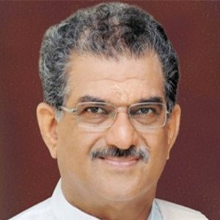
Param Samrakshak Margadarshak & Founder Trustee
Dr. D. Veerendra Heggade
Padma Vibhushan Dr. D. Veerendra Heggade is the Hereditary Dharmadhikari of Shri Kshetra Dharmasthala, one of India's most respected centres of faith, service, and cultural heritage. Since assuming this responsibility in 1968, he has devoted his life to advancing rural development, education, healthcare, environmental conservation, and the preservation of India's cultural and spiritual legacy.
A nationally respected philanthropist and institution builder, Dr. Heggade has led numerous transformative initiatives through the Shri Dharmasthala Manjunatheshwara (SDM) institutions and the Shri Kshethra Dharmasthala Rural Development Project (SKDRDP). In recognition of his extraordinary contribution to public service, he was conferred the Padma Vibhushan, India's second-highest civilian honour, in 2015, and was nominated to the Rajya Sabha in 2022.
As the Param Samrakshak, Margadarshak, and Founder Trustee of the Acharya Shanti Sagar Foundation, his vision and guidance inspire our commitment to preserving India's manuscript heritage while ensuring that conservation efforts remain deeply rooted in service, authenticity, and social responsibility.

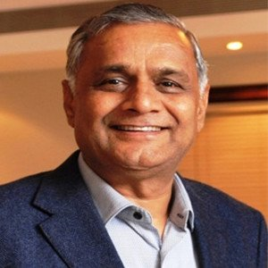
Settlor, Visionary & Founder Trustee
Shri Ashok Patni
Shri Ashok Patni is a successful entrepreneur and philanthropist whose vision founded this foundation. As Chairman Emeritus of the R.K. Group and founder of R.K. Marble & Wonder Cement he built businesses of scale while maintaining a deep commitment to environmental stewardship and welfare for the underprivileged. His belief—that success in business must translate to responsibility to society—shaped the foundation's core values. Shri Patni brought together the trustees who share this vision of combining social service with heritage preservation.

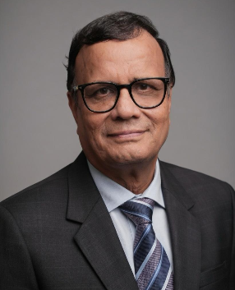
President & Founder Trustee
Shri Anil Kumar Sethi
Chairman of ADD Group and long-time infrastructure leader, Shri Sethi has pioneered innovations in water, power, sanitation, and smart city development. As the founder of Pump Academy and iPUMPNET technology, he has created impact in critical sectors. His commitment to the foundation is personal: he leads major charitable health, education and heritage-preservation initiatives. As President, he provides strategic leadership and ensures operational excellence.
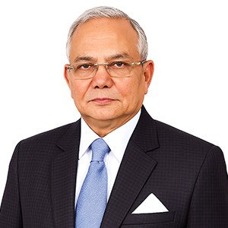
Working President & Founder Trustee

Shri Rajendra Kumar Kataria
Driving force of Kataria Automobiles, India's leading Maruti-Suzuki dealership with 125+ touchpoints and record-breaking sales milestones, Shri Kataria demonstrates that customer-centric, innovation-led leadership creates both business excellence and social responsibility. His philanthropic contributions in education, health and environment reflect his belief that prosperity must serve the community.

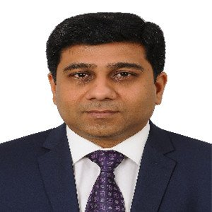
Secretary & Founder Trustee
Shri Rakesh Kumar Jain
FCA and FCS with expertise in insolvency, valuation and corporate governance, Shri Jain brings rigorous financial and organizational discipline to the foundation. His deep involvement in social activities and leadership of large-scale humanitarian initiatives—including prosthetic limb camps—demonstrate strong organizational capacity and humanitarian commitment. He served as the National Secretary during the Bahubali Mahamastakabhisheka held at Shravanabelagola in 2018.

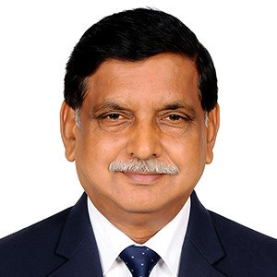
Founder Trustee
Shri Suresh Sablawat
Leader of Readiprint International, a reputable printing and publishing enterprise, Shri Sablawat has devoted himself to preserving cultural heritage and advancing community welfare. A key trustee at major institutions, he understands that heritage preservation requires both expertise and genuine commitment to stewardship.
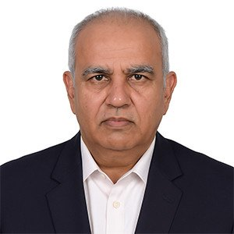
Founder Trustee
Shri Vinod Doddanavar
Secretary of Bharatesh Education Trust with expertise spanning pharma research, academia, and family enterprises, Shri Doddanavar has expanded educational access, supported heritage restoration, and launched major social projects including COVID care facilities. His background in diverse sectors brings comprehensive understanding of societal challenges and solutions and also served as the National Secretary during the Bahubali Mahamastakabhisheka held at Shravanabelagola in 2018.

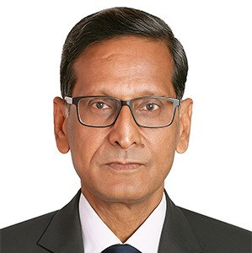
Founder Trustee
Shri Ashok Kumar Jain
Retired businessman with senior positions across key community organizations, Shri Jain holds significant responsibility for heritage conservation and community cohesion. His role in management of cultural institutions reflects his understanding that heritage preservation is both a financial and moral responsibility.

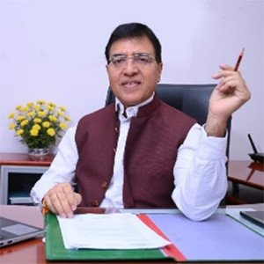
Chief Advisor & Mentor
Shri Rajeev Jain
Shri Rajeev Jain, former Director General of the Press Information Bureau (Government of India, IFS: 1991), brings three decades of distinguished service in national government leadership. His tenure has spanned senior strategic and communication roles across key ministries including Finance, Defence, Civil Aviation, Commerce & Industry, and others.
Recognizing the national importance of safeguarding India's ancient knowledge traditions and making them accessible through modern digital platforms, Shri Rajeev Jain formally associated with the foundation to mentor its strategic expansion, institutional partnerships, policy alignment, and capacity building.
Under his guidance, the foundation's conservation programme is being positioned as a scalable national heritage initiative that integrates scientific conservation practices, digital preservation, research access, and public engagement in alignment with India's broader cultural preservation priorities.

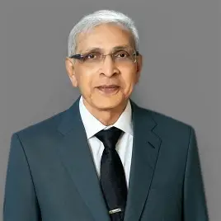
Dr. Jasvant Modi
Advisor, Acharya Shanti Sagar Foundation
Dr. Jasvant Modi is a retired gastroenterologist and philanthropist based in Los Angeles, with a distinguished career in healthcare and community service.
With decades of experience in medicine, institution-building, and philanthropy, he has supported initiatives in healthcare, education, and Jain heritage and community development across India, the United States, and Europe.
He has also held leadership roles in Jain community organisations, bringing a strong commitment to service and social responsibility.
His experience in healthcare, philanthropy, and community engagement adds valuable perspective to the Foundation’s work.
As an Advisor to ASSF, Dr. Modi provides guidance towards strengthening its vision and advancing its commitment to heritage preservation and service to society.

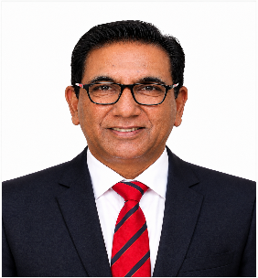
Dr. Ashok Jetawat
Advisor, Acharya Shanti Sagar Foundation
Dr. Ashok Jetawat is an academic, researcher, corporate trainer, and e-governance specialist with extensive experience in education, professional development, and institutional leadership.
With advanced qualifications and a Ph.D. in e-Governance, he has contributed extensively to research, mentoring, leadership development, and capacity building.
His professional expertise spans organisational development, team building, productivity, e-Governance, and professional training.
His experience in knowledge development, mentoring, and institution-building brings valuable perspective to the Foundation’s organisational growth.
As an Advisor to ASSF, Dr. Jetawat provides strategic guidance to strengthen its programmes, institutional capabilities, and long-term impact.

